STEP 1:

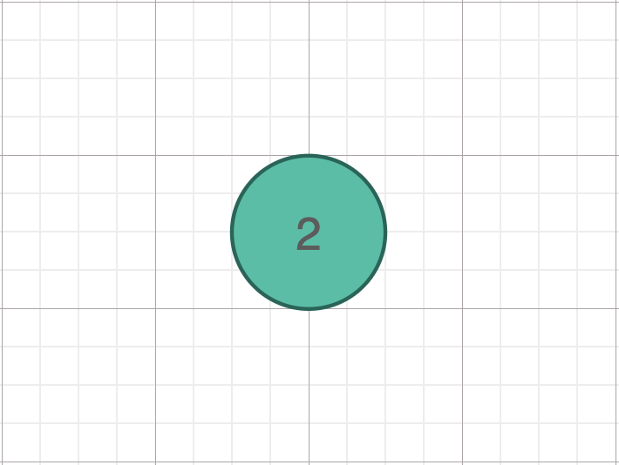

The tree has no leaf yet. So [2] would be the root.

STEP 2:

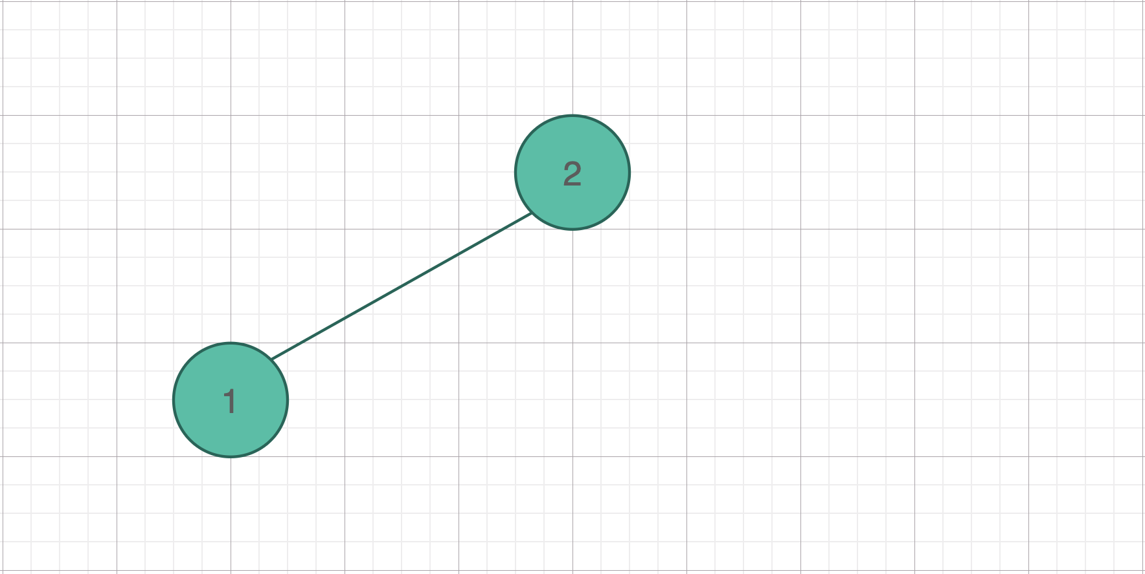

[1] is smaller than [2]. So [1] goes to [2]’s left branch.

STEP 3:

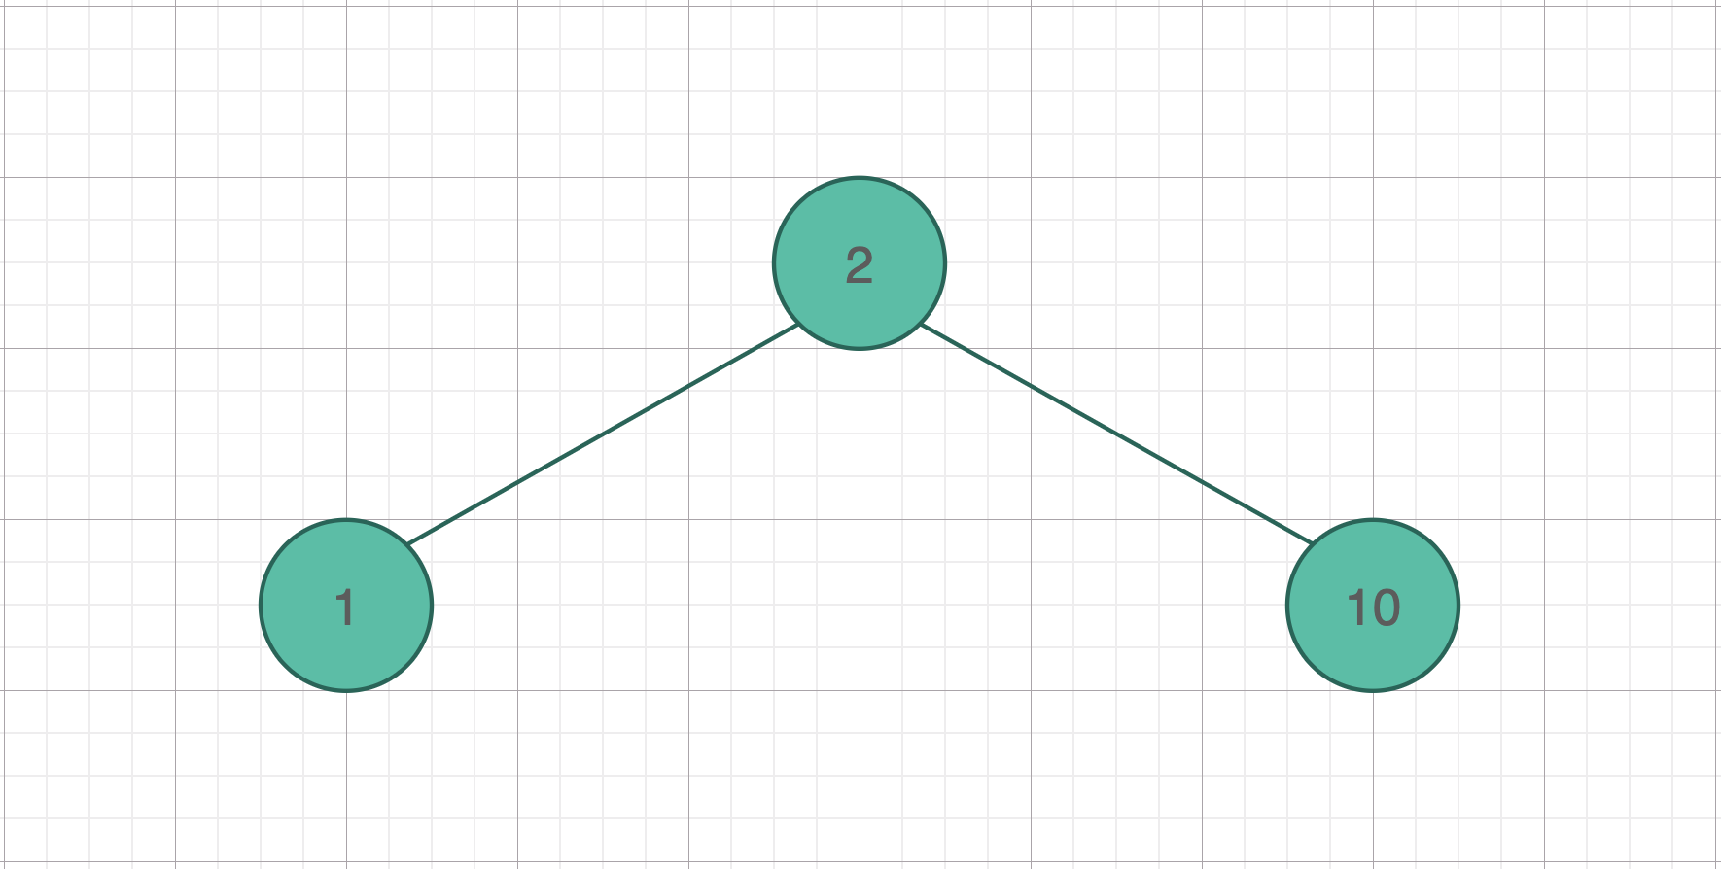

[10] is larger than [2]. So [10] goes to [2]‘s right branch

STEP 4:

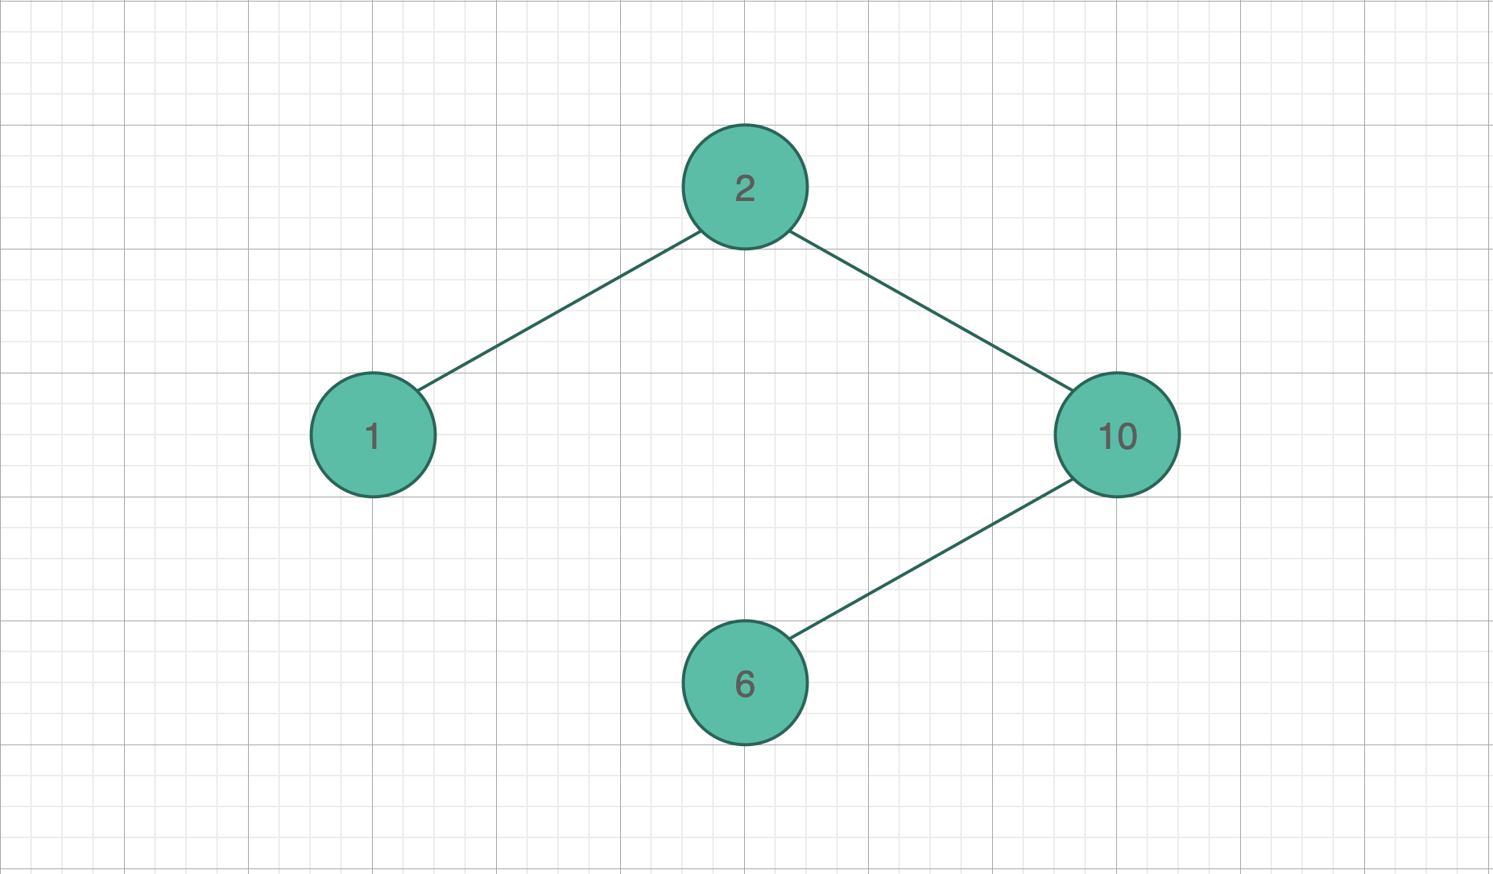

[6] is larger than [2], but smaller than [10]. So [6] goes to [2]’s right branch, [10]’s left branch.

STEP 5:

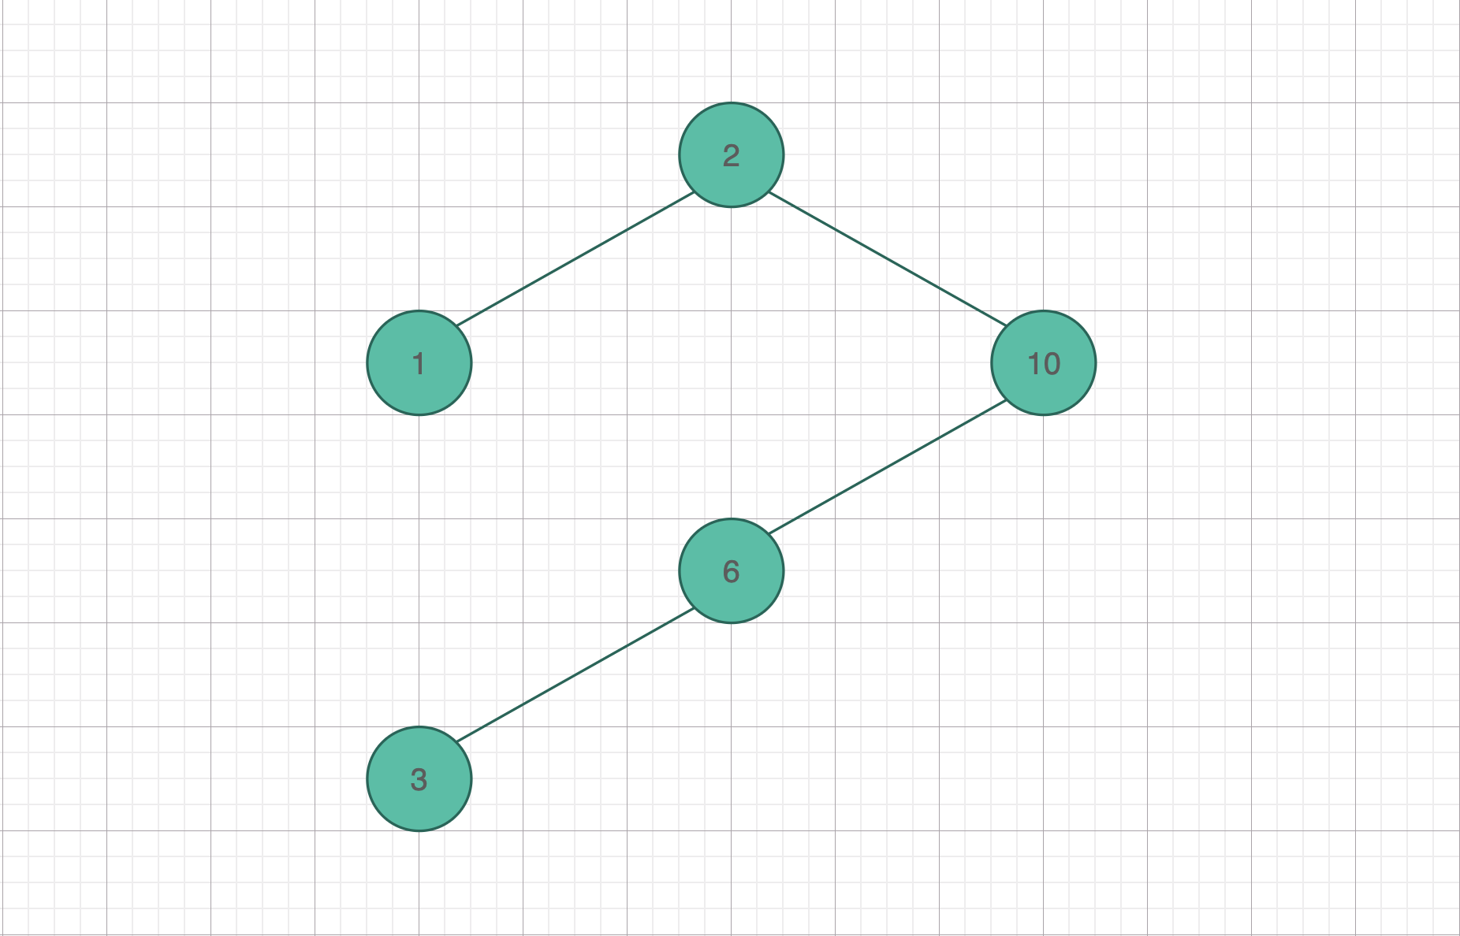

[3] is larger than [2], but smaller than [10] and [6]. So [3] goes to [2]’s right branch, [10] and [6]’s left branch.

STEP 6: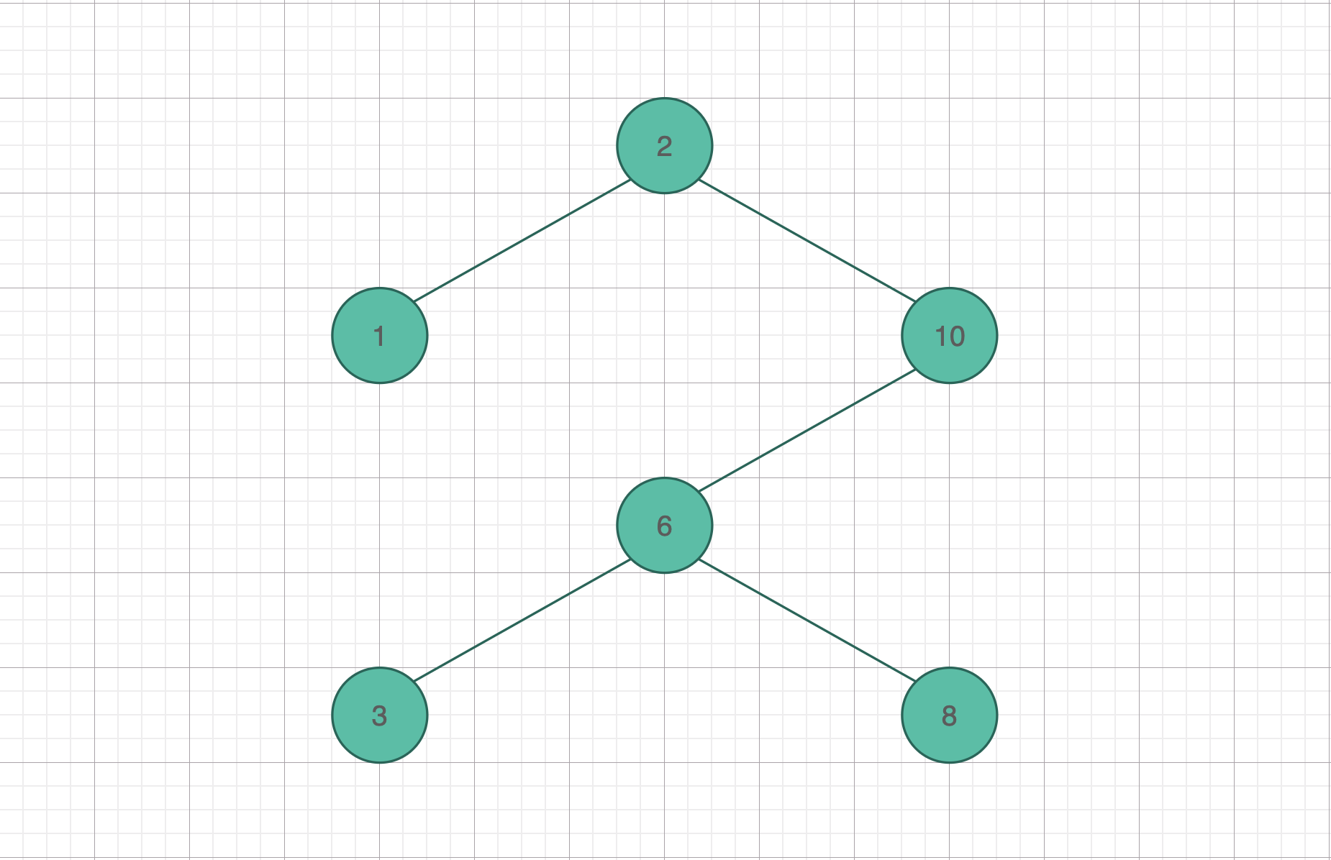

[8] is larger than [2], but smaller than [10], and larger than [6]. So [8] goes to [2]’s right branch, [10]’s left branch then [6]’s right branch.

STEP 7:

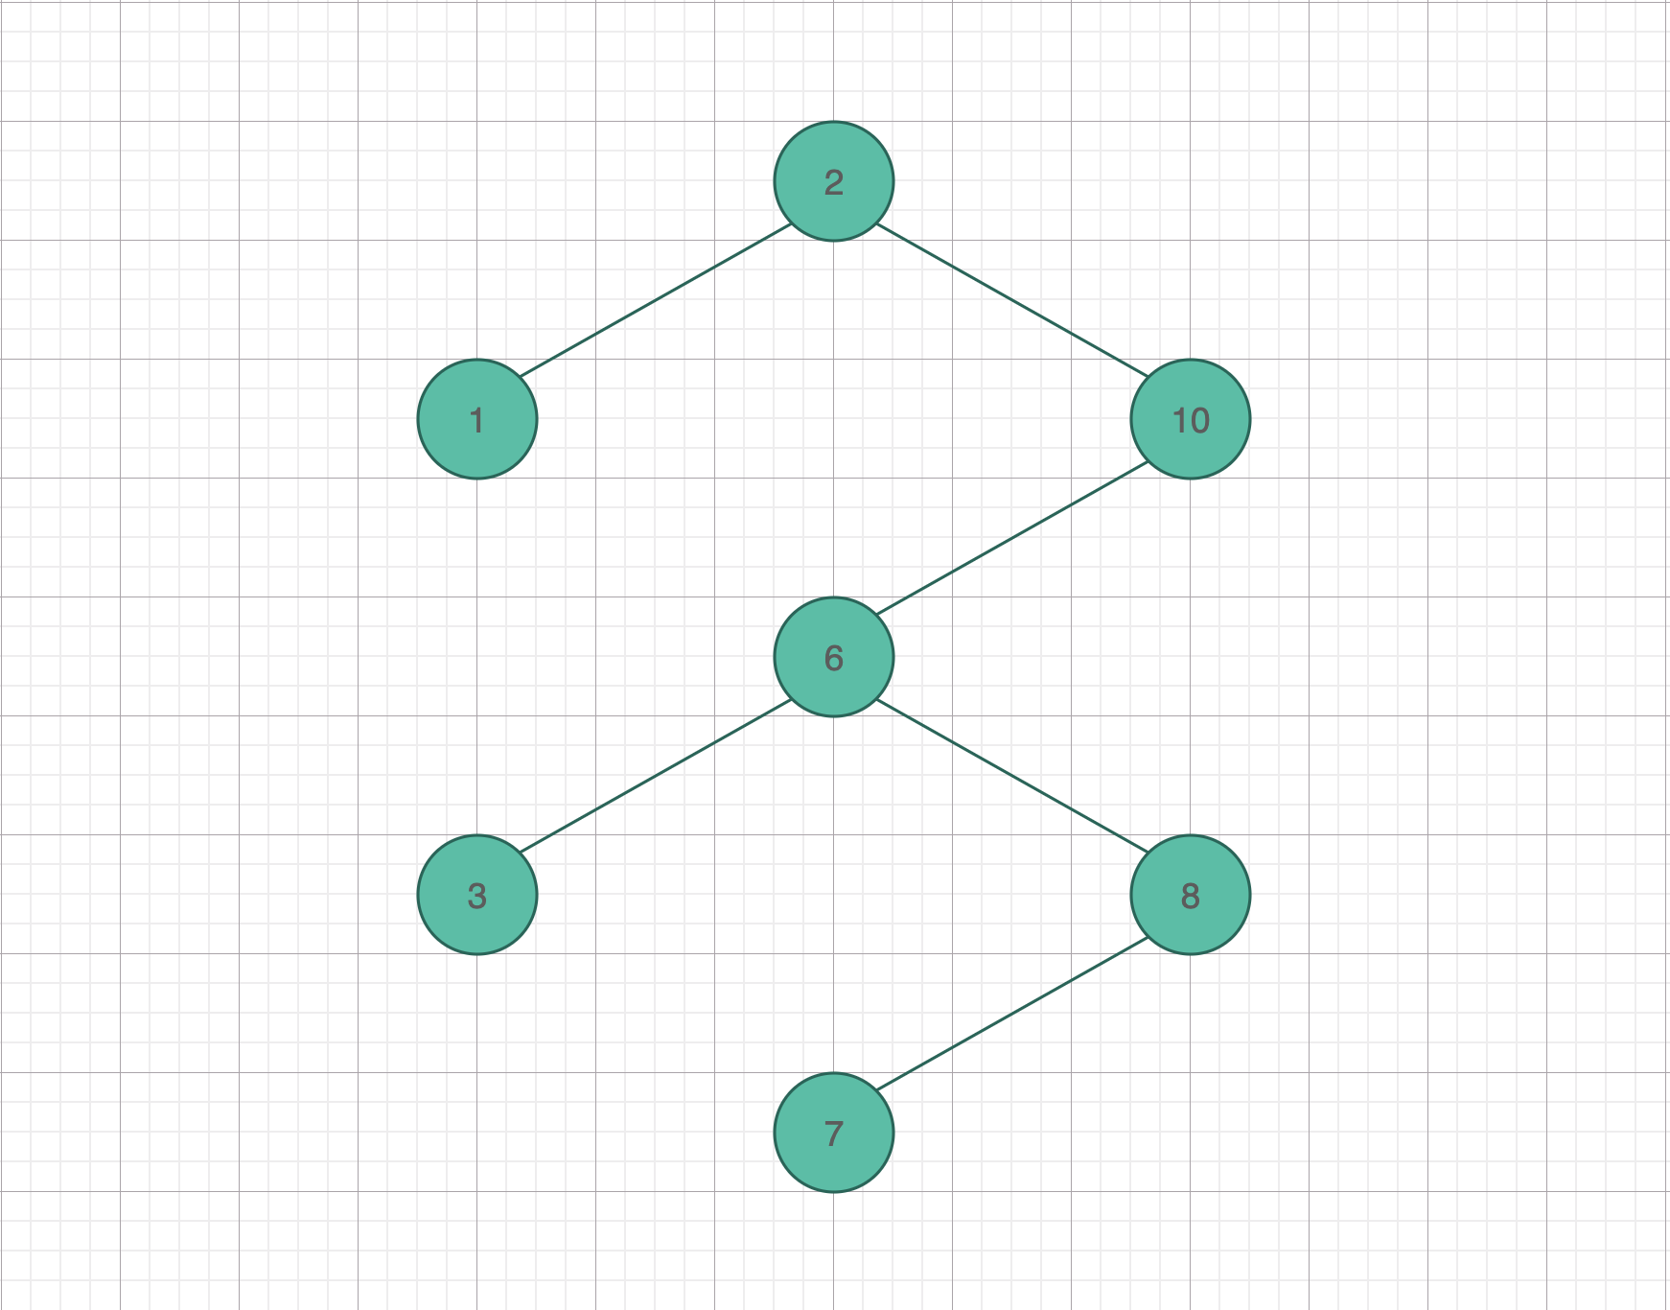

[7] is larger than [2], but smaller than [10], larger than [6], but smaller than [8]. So [7] goes to [2]’s right branch, [10]’s left branch, [6]’s right branch then [8]’s left branch.

STEP 8:

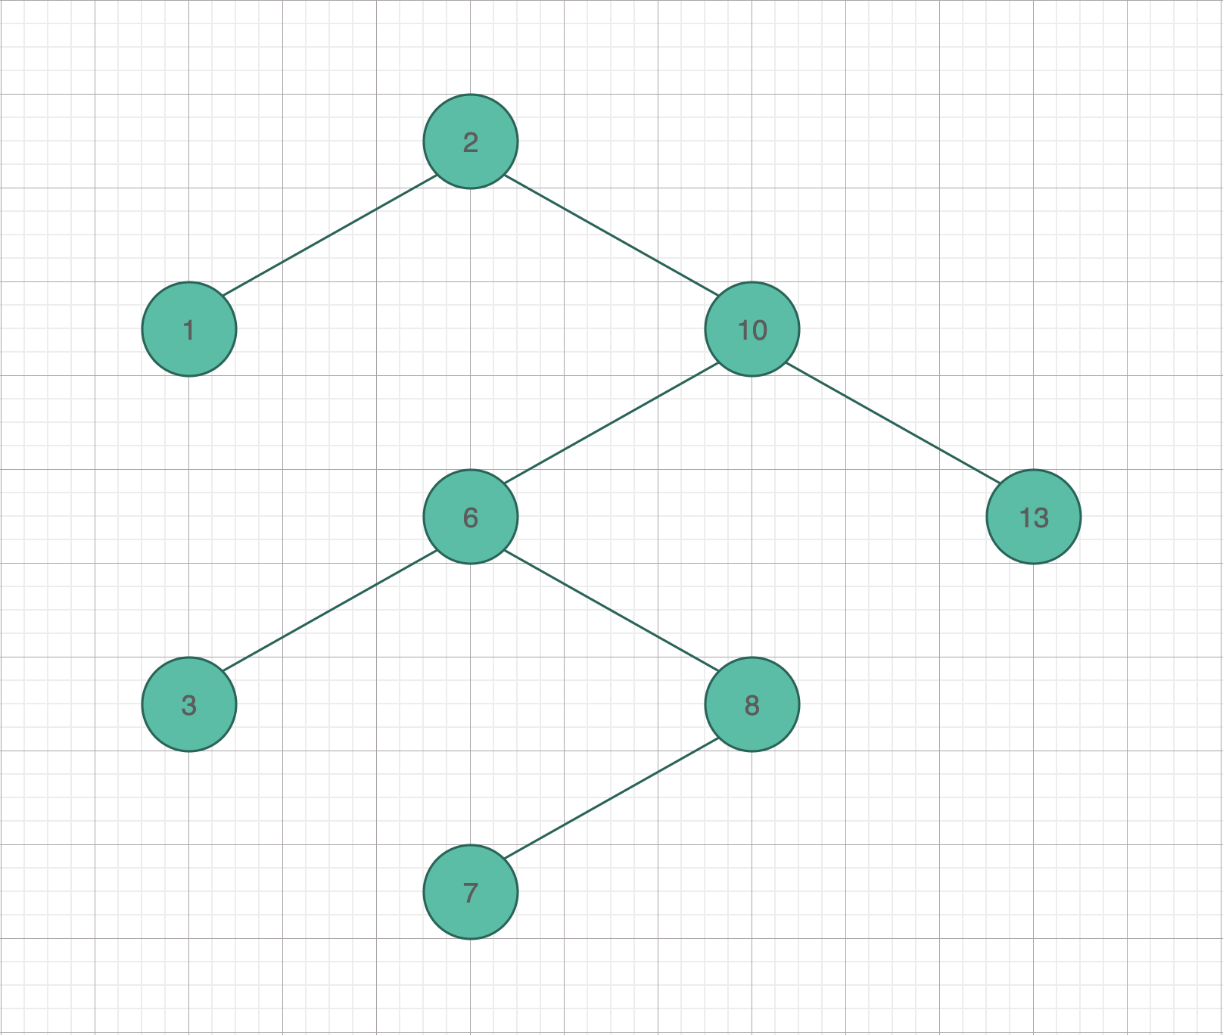

[13] is the largest key so far. So [13] goes to the right most leaf.

STEP 9:

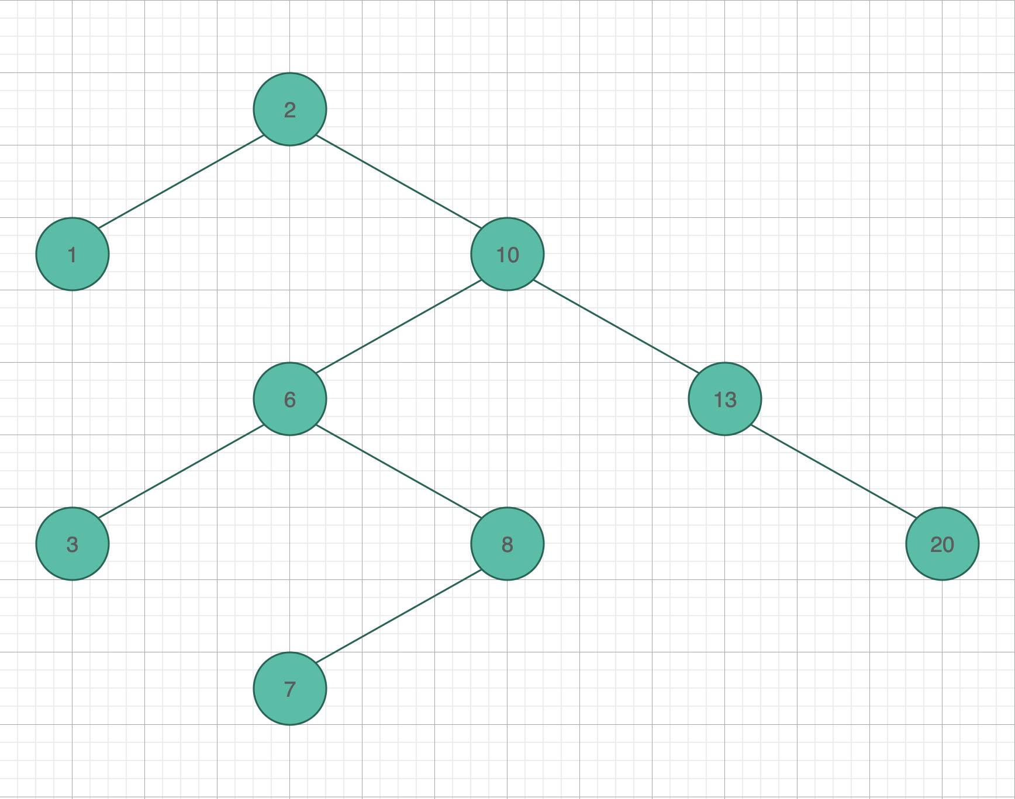

[20] is the largest key so far. So [20] goes to the right most leaf.

Insert value [14]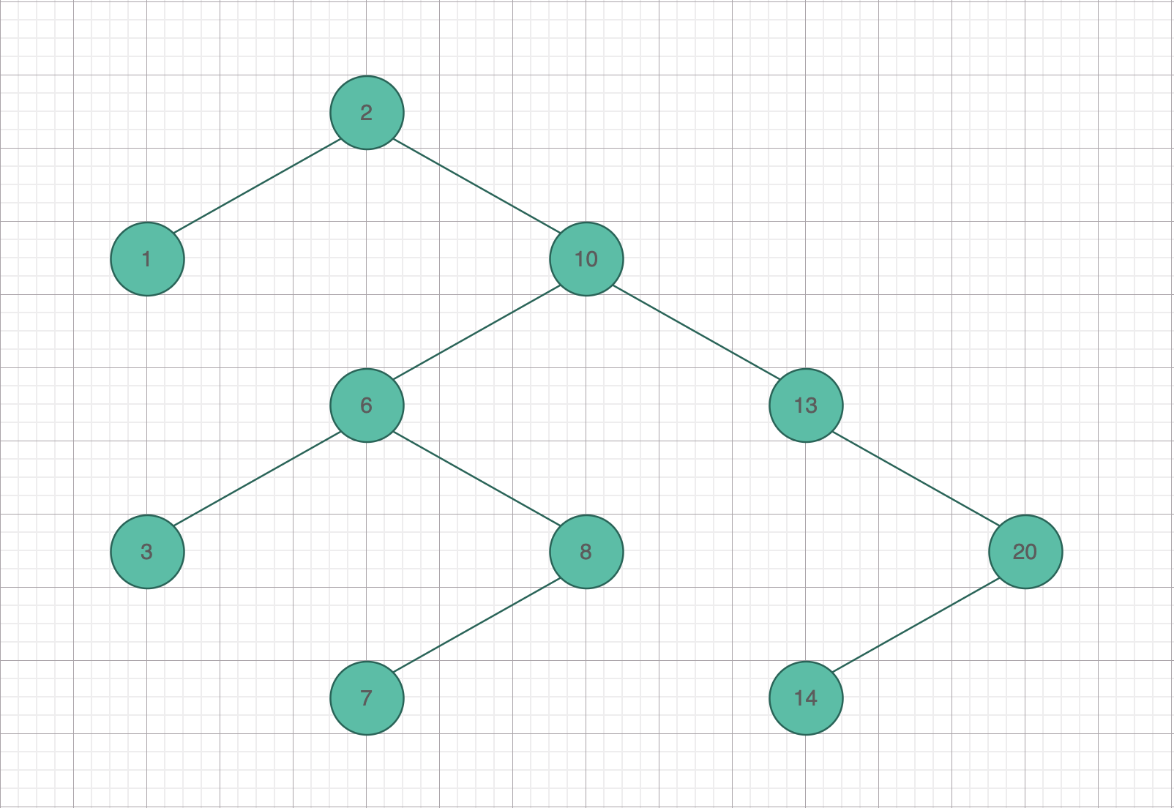

[14] is larger than [2], larger than [10], larger than [13], but smaller than [20]. So [14] goes to [20]’s left branch.

Insert value [0]

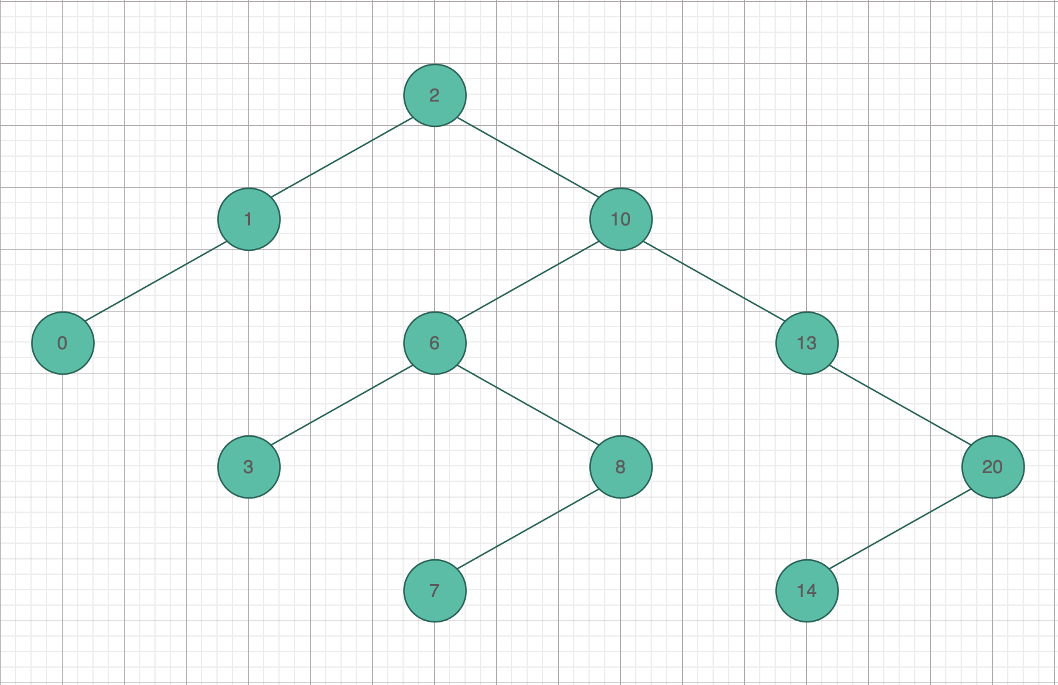

[0] is the smallest key so far. So [0] goes to the left most leaf.

Insert value [35]

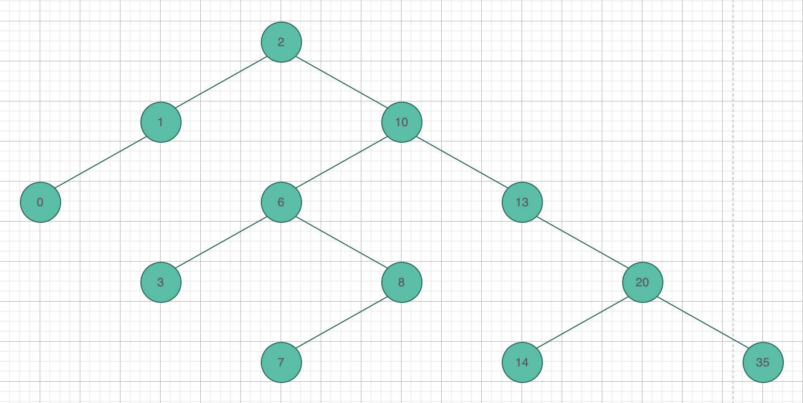

[35] is the largest key so far. So [35] goes to the right most leaf.

Delete value [6].

Case 1: Find the left most leaf of [6]’s right branch: [7]. Then swap these leaves’s values.

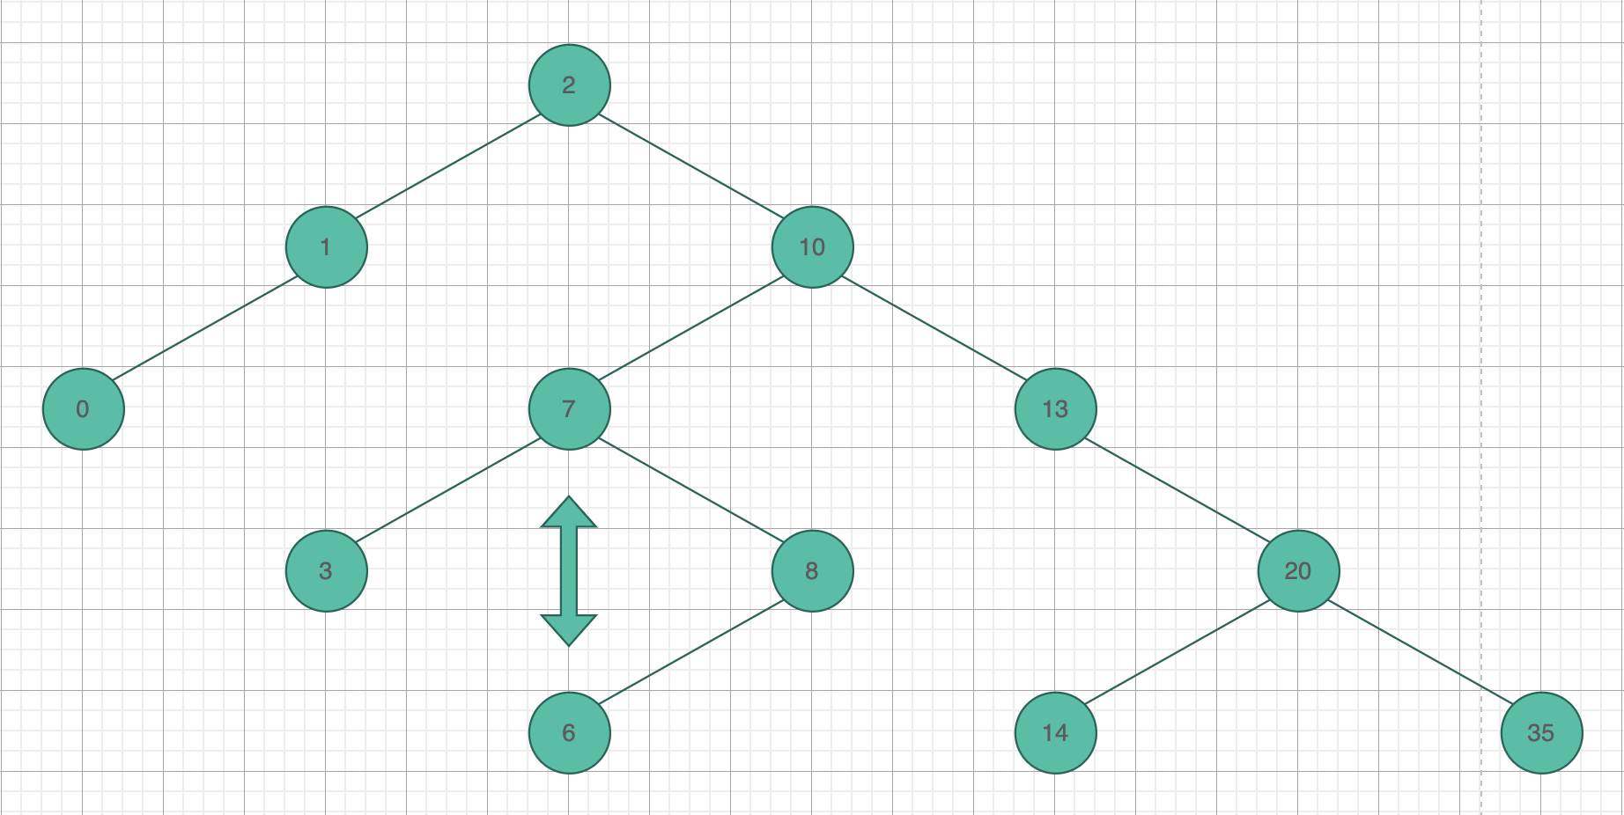

Lastly, delete the swapped left most leaf.

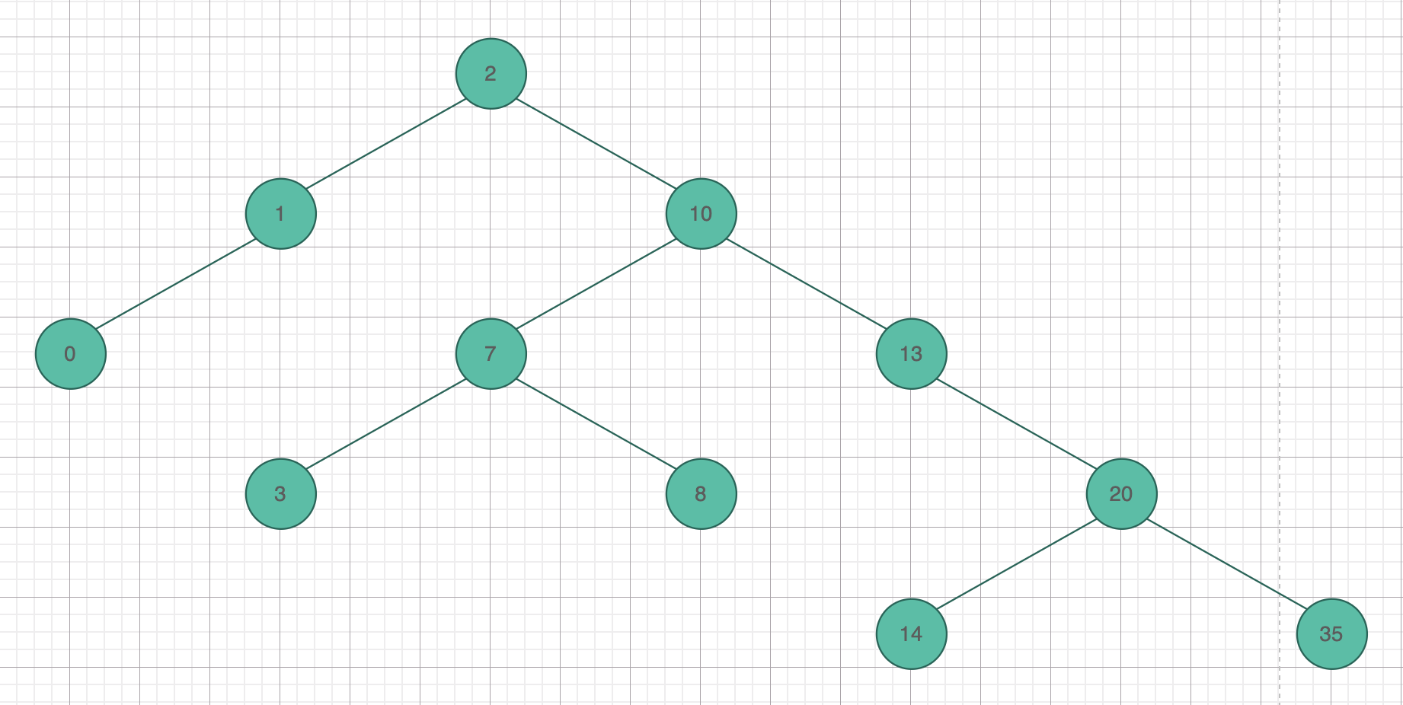

New tree after deleted value [6].

Case 2:

Find the right most leaf of [6]’s left branch: [3]. Then swap these leaves’s value.

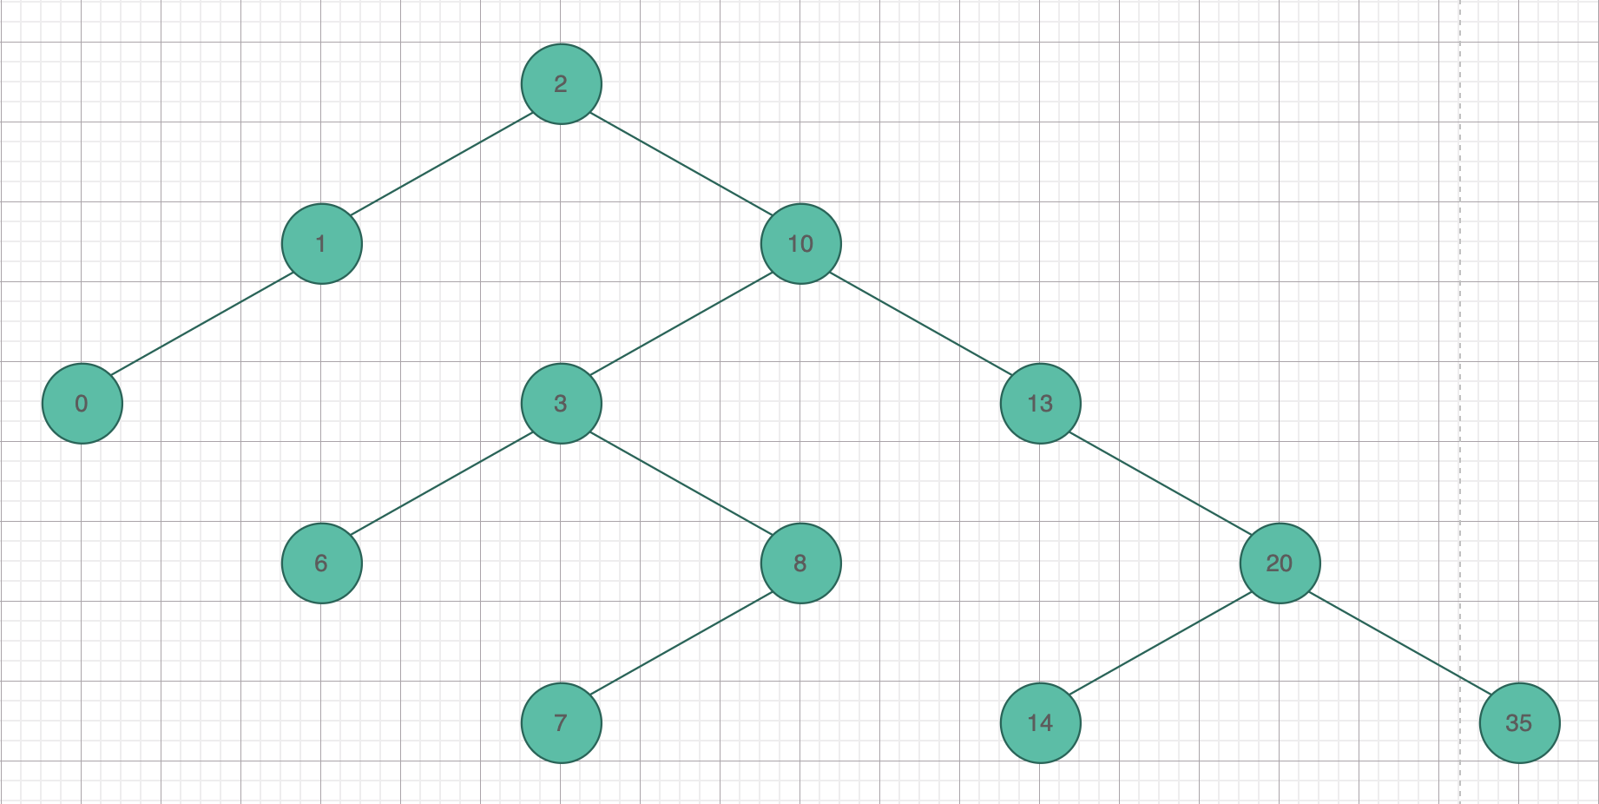 Lastly, delete the swapped right most leaf.

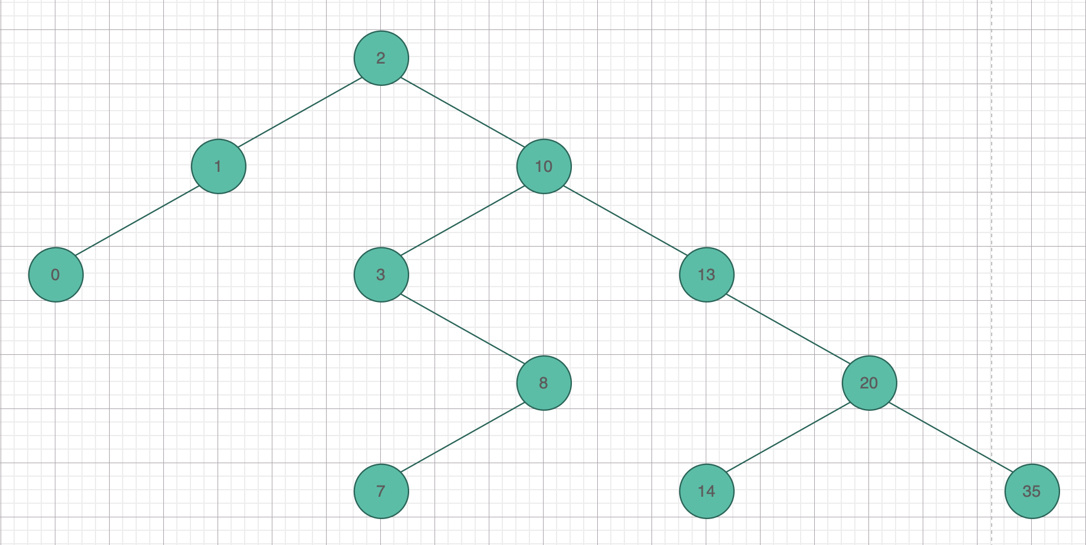

New tree after deleted [6].

Case 1: Delete value [13]

Since [13] has no left child, find the left most leaf of [13]’s right branch: [14]. Then swap values.

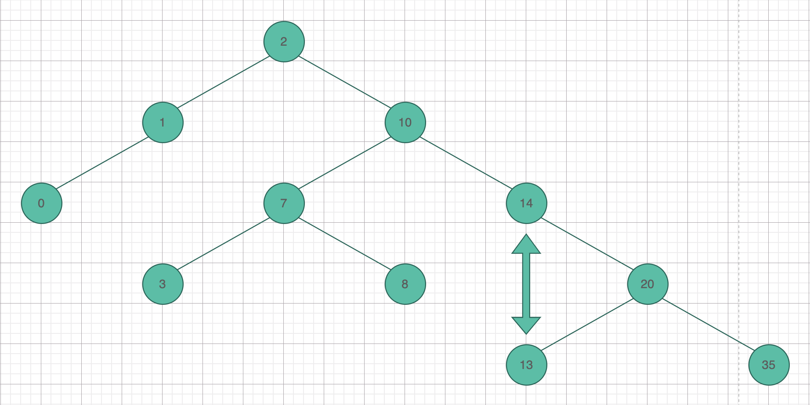

Lastly, delete the swapped left most leaf.

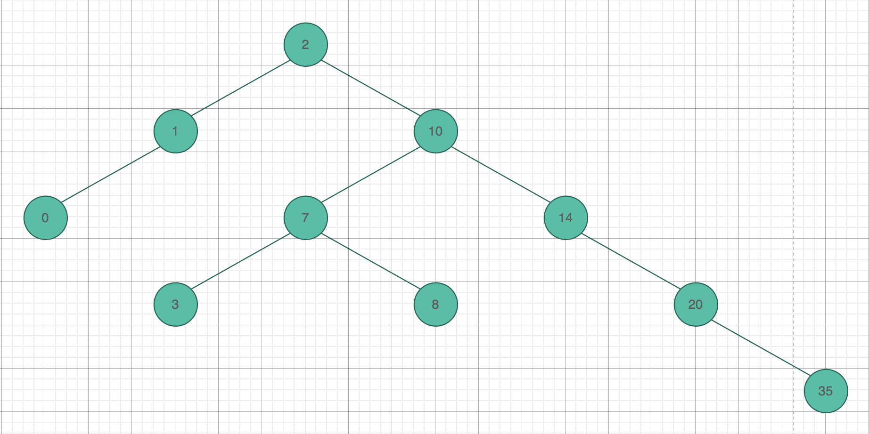

New tree after deleted [13].

Case 2: Delete value [13]

Since [13] has no left child, find the left most leaf of [13]’s right branch: [14]. Then swap values.

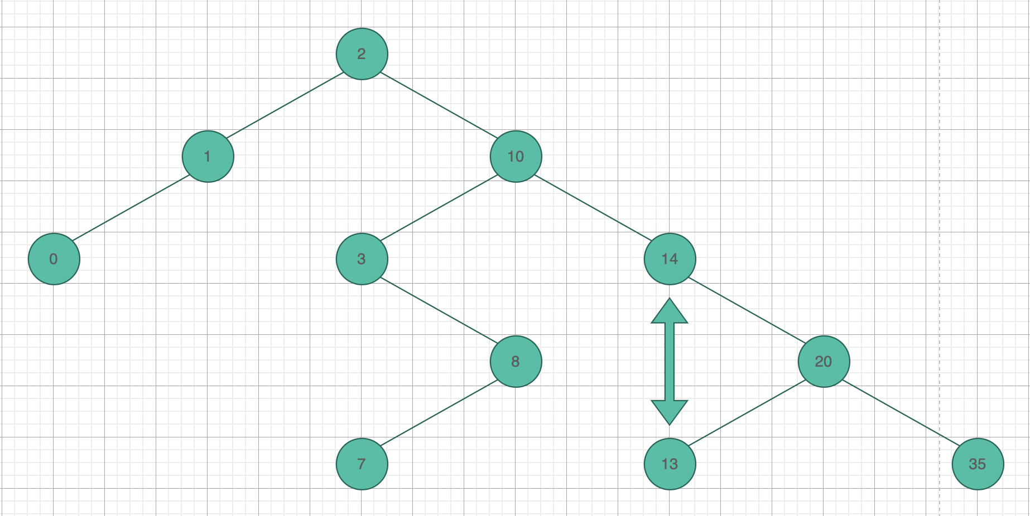

Lastly, delete the swapped left most leaf.

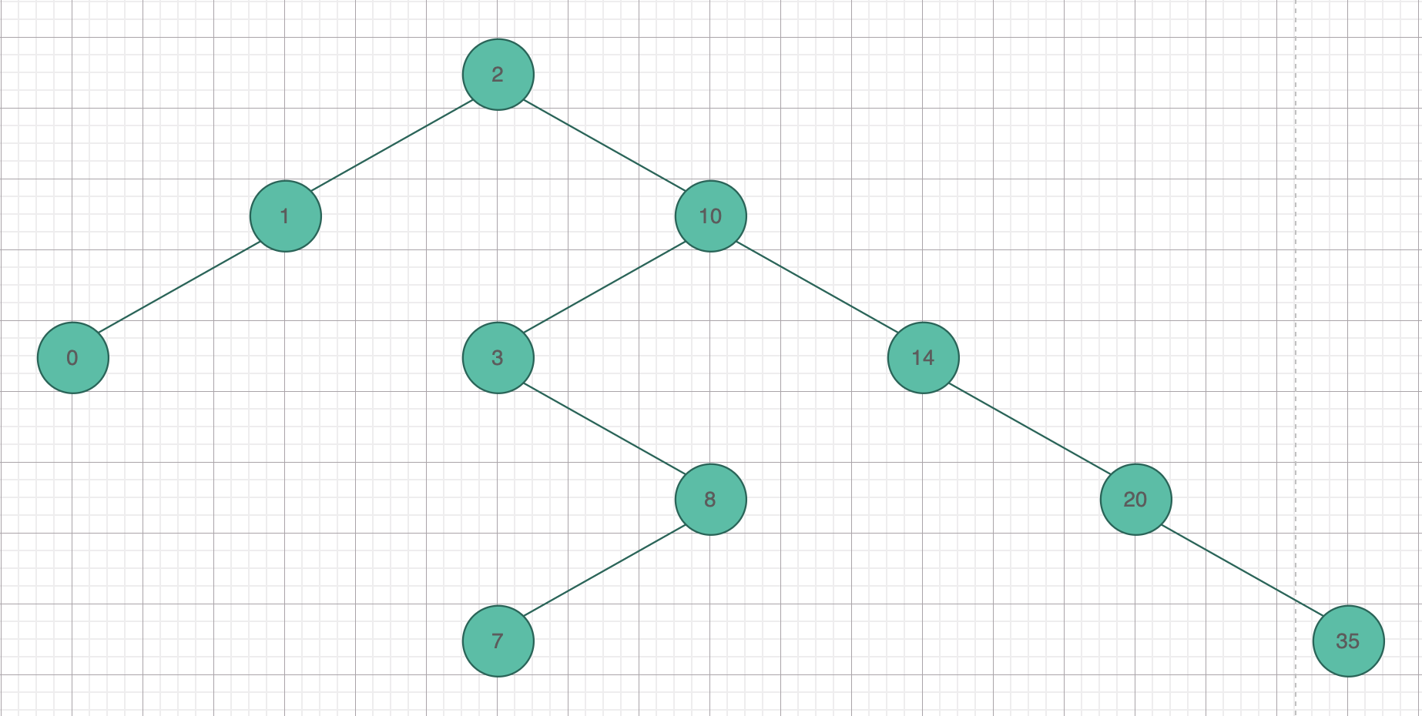

New tree after deleted [13].

Case 1: Delete value [35]

Since [35] has no child, it can be delete right away.

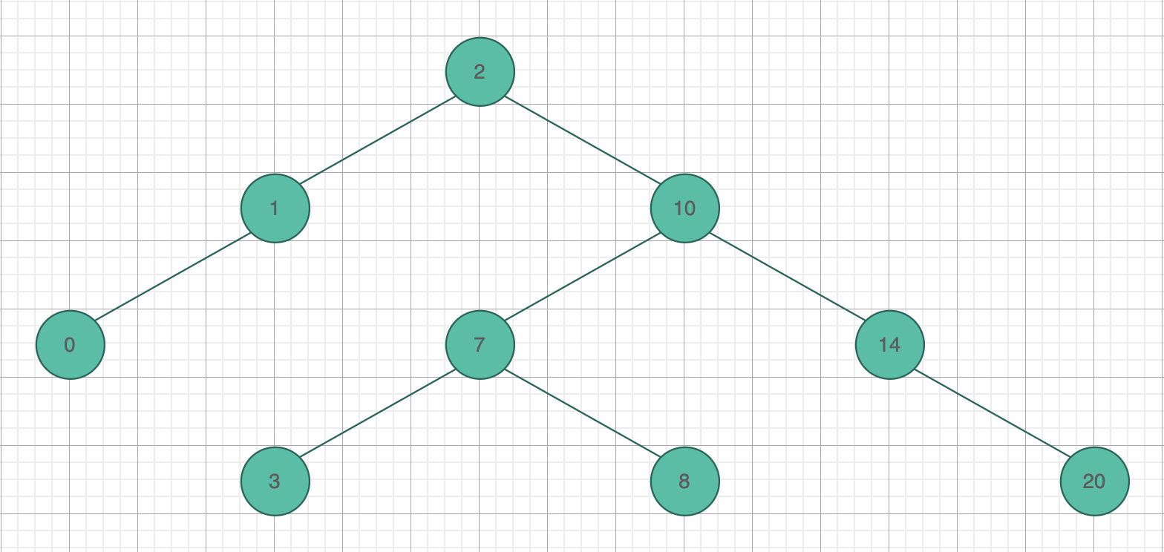

Case 2: Delete value [35]

Since [35] has no child, it can be delete right away.

